

<EVENT_MANAGEMENT>

Documentation

|  |  |
| --- | --- |
| Authors | C2209i-Group 1 |
| 1. Đặng Đình Thuận  2. Lê Tiến Tài  3. Phạm Doãn Toàn  4. Lê Thành Đạt |
| Date | 29/05/2023 |
| Instructor | Tô Hoàng Anh |

- Hà Nội, 2023 -

Index

B

Boundaries of the System 4

C

Customer Requirements Specification 4

D

Database Design *8*

E

Entity Relationship Diagram *7*

H

Hardware and Software Requirements 4

P

Abstract *3*

Problem Definition **3**

S

Sitemap 12

System Designs 6

System function *5*

T

Task sheet 37

The Current System *3*

The Proposes Sytem *4*

U

Users of the System *4*

V

Validation Checklists 40

1. **Problem Definition**
   1. *Abstract*

* Events play an important role in our society. Anything happening around us or an activity, important or not, can be referred as an event. Individuals often find they lack the expertise and time to plan events themselves. Independent planners are needed to step in and give these special events the attention they deserve. In the current scenario, planning an event requires a lot of patience and hustle bustle right from deciding the theme to deciding venue and events. Lots of factors need to be considered while making each decision. Furthermore, once the party is planned, lots of issues suddenly emerge, such as maintaining low noise levels after a particular time, or neighbors complaining about the noise levels, etc. ruining the whole carefully prepared party/event. In order to foresee and prevent such problems, we have come up with an easy-to-use website to effectively assist customers with organizing the perfect event.
* Understanding these issues from the perspective of customers and managers, we have created a website to help manage events. On the user side, we will provide specific and detailed information about each type of event such as wedding party, business party and private party with facilities, equipment and service packages, etc. On the admin side, we will provide features for customer management and event management such as tracking customer visits, adding, editing, deleting services, revenue management, business data analysis business. Our website will be the swift, straightforward and compelling connection between businesses and customers.
  1. *The Current System*
* Our website will demonstrate the types of events and services provided.

+ The interface on the home page "Home" will display the services, introduction about the business.

+ Details of each event service and organized events.

* 1. *The Proposes System*

- The purpose is to help users access and track items on the website easily. We have created a website with the following features:

* Registration and login function.
* Function to add comments on articles.

1.3.1 Boundaries of the System

Users can use functions such as registration, login, view event services, add comments and contacts.

1.3.2 Hardware and Software Requirements

Hardware:

* A minimum computer system that will help you access all the tools in the courses is a Pentium 166 or better
* 64 Megabytes of RAM or better

Software:

* Notepad.HTML editor
* Dreamweaver
* IE 5.0/ Netscape 6.0

**2**. **Customer Requirements Specification**

*2.1* *Users of the System*

Users can only use functions such as registration, login, view event services, add comments and contact.

1. Customers

* Log in and log out.
* View event about service, equipment, performer.
* Manage user account information.

1. Admin

* User account management.
* Information management event
* Manage customers orders

*2.2* *System function*:

* Customers
  1. Event

|  |  |
| --- | --- |
| Input | Select event to view event content |
| Process | Access data to get event information |
| Output | Display detailed content of the selected event |

* 1. Contact

|  |  |
| --- | --- |
| Input | Send contact information and checkout |
| Order | Access data to get information |
| Output | Display information that has been set |

* Admin

1. Add new event services

|  |  |
| --- | --- |
| Input | Enter new post information |
| Order | Validate, submit and insert a new record in the database |
| Output | Show the new event service |

1. Edit products

|  |  |
| --- | --- |
| Input | Input new information |
| Order | Validate, submit and update database |
| Output | Show the event service after edit |

1. Delete products

|  |  |
| --- | --- |
| Input | Select the event service to delete |
| Order | Delete the record in the database |
| Output | Return the home site after deleting the event service |

1. Manage user orders

|  |  |
| --- | --- |
| Input | Select customer order information |
| Order | Check orders information stored in the database |
| Output | Show order information |

1. Manage user account

|  |  |
| --- | --- |
| Input | Select user information |
| Order | Access data to get user information |
| Output | Display user information and allow edit, delete information |

1. **System Designs**
   1. *Entity Relationship Diagram*

* Entity-relationship

username

admin

email

id_admin

address

password

phone

* 1. *Database Design*
* Table relationship

The relationship between the tables in the database is represented through a diagram:

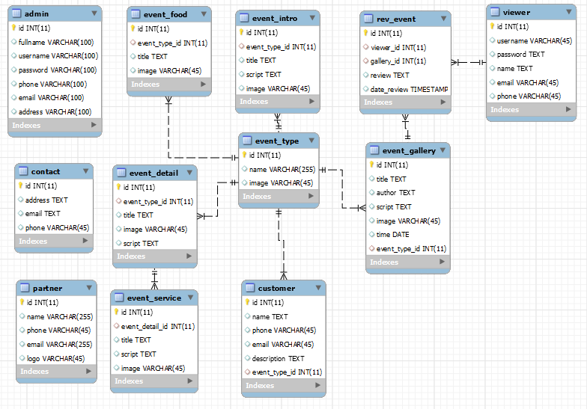

**Image 3: Table Relationship**

* **Table detail**
* **admin**

|  |  |  |  |
| --- | --- | --- | --- |
| **Column** | **Data type** | **Constraint** | **Description** |
| **id** | **int** | **Primary Key** | **Admin id** |
| **Fullname** | **varchar(100)** |  | **Admin name** |
| **username** | **varchar(100)** |  | **Login name** |
| **password** | **varchar(100)** |  | **Password** |
| **phone** | **varchar(100)** |  | **Phone number** |
| **email** | **varchar(100)** |  | **Email** |
| **address** | **varchar(100)** |  | **Address** |

* **event_type**

|  |  |  |  |
| --- | --- | --- | --- |
| **Column** | **Data type** | **Constraint** | **Description** |
| **id** | **int** | **Primary Key** | **Event type id** |
| **name** | **varchar(255)** |  | **Event name** |
| **image** | **varchar(45)** |  | **Event image** |

* **event_intro**

|  |  |  |  |
| --- | --- | --- | --- |
| **Column** | **Data type** | **Constraint** | **Description** |
| **id** | **int** | **Primary Key** | **Intro id** |
| **event_type_id** | **int** | **Foreign Key** | **event_type.id** |
| **title** | **text** |  | **Intro title** |
| **script** | **text** |  | **Intro script** |
| **image** | **varchar(45)** |  | **Intro image** |

* **event_detail**

|  |  |  |  |
| --- | --- | --- | --- |
| **Column** | **Data type** | **Constraint** | **Description** |
| **id** | **int** | **Primary Key** | **Detail id** |
| **event_type_id** | **int** | **Foreign Key** | **event_type.id** |
| **title** | **text** |  | **Detail title** |
| **script** | **text** |  | **Detail script** |
| **image** | **varchar(45)** |  | **Detail image** |

* **event_service**

|  |  |  |  |
| --- | --- | --- | --- |
| **Column** | **Data type** | **Constraint** | **Description** |
| **id** | **int** | **Primary Key** | **Event service id** |
| **event_detail_id** | **int** | **Foreign Key** | **event_detail.id** |
| **title** | **text** |  | **Service title** |
| **script** | **text** |  | **Service script** |
| **image** | **varchar(45)** |  | **Service image** |

* **event_food**

|  |  |  |  |
| --- | --- | --- | --- |
| **Column** | **Data type** | **Constraint** | **Description** |
| **id** | **int** | **Primary Key** | **Food id** |
| **event_type_id** | **int** | **Foreign Key** | **event_type.id** |
| **title** | **text** |  | **Food title** |
| **image** | **varchar(45)** |  | **Food image** |

* **event_gallery**

|  |  |  |  |
| --- | --- | --- | --- |
| **Column** | **Data type** | **Constraint** | **Description** |
| **id** | **int** | **Primary Key** | **Gallery id** |
| **event_type_id** | **int** | **Foreign Key** | **event_type.id** |
| **title** | **text** |  | **Gallery title** |
| **author** | **text** |  | **Gallery author** |
| **script** | **text** |  | **Gallery script** |
| **image** | **varchar(45)** |  | **Gallery image** |
| **time** | **date** |  | **Gallery date** |

* **customer**

|  |  |  |  |
| --- | --- | --- | --- |
| **Column** | **Data type** | **Constraint** | **Description** |
| **id** | **int** | **Primary Key** | **Customer id** |
| **event_type_id** | **int** | **Foreign Key** | **event_type.id** |
| **name** | **text** |  | **Customer name** |
| **phone** | **varchar(45)** |  | **Customer phone** |
| **email** | **varchar(45)** |  | **Customer email** |
| **description** | **text** |  | **Customer note** |

* **viewer**

|  |  |  |  |
| --- | --- | --- | --- |
| **Column** | **Data type** | **Constraint** | **Description** |
| **id** | **int** | **Primary Key** | **User id** |
| **username** | **varchar(45)** |  | **Login name** |
| **password** | **text** |  | **Password** |
| **name** | **text** |  | **User name** |
| **phone** | **varchar(45)** |  | **User phone** |
| **email** | **varchar(45)** |  | **User email** |

* **rev_event**

|  |  |  |  |
| --- | --- | --- | --- |
| **Column** | **Data type** | **Constraint** | **Description** |
| **id** | **int** | **Primary Key** | **Review id** |
| **event_type_id** | **int** | **Foreign Key** | **event_gallery.id** |
| **viewer_id** | **int** | **Foreign Key** | **viewer.id** |
| **review** | **text** |  | **Comment** |
| **date_review** | **timestamp** |  | **Date comment** |

* **contact**

|  |  |  |  |
| --- | --- | --- | --- |
| **Column** | **Data type** | **Constraint** | **Description** |
| **id** | **int** | **Primary Key** | **Contact id** |
| **address** | **text** |  | **Address contact** |
| **email** | **text** |  | **Email contact** |
| **phone** | **varchar(45)** |  | **Phone contact** |

* **partner**

|  |  |  |  |
| --- | --- | --- | --- |
| **Column** | **Data type** | **Constraint** | **Description** |
| **id** | **int** | **Primary Key** | **Partner id** |
| **name** | **varchar(255)** |  | **Partner name** |
| **email** | **varchar(255)** |  | **Partner email** |
| **phone** | **varchar(45)** |  | **Partner phone** |
| **logo** | **varchar(45)** |  | **Partner logo** |

* 1. *Sitemap*

Home Page

Event

Register

Login

Gallery

Gallery page

Event page

Register page

Login page

Image 4: Site map

* 1. System functions design
* User’s interface
* Header



Image 5: Header website

* Body

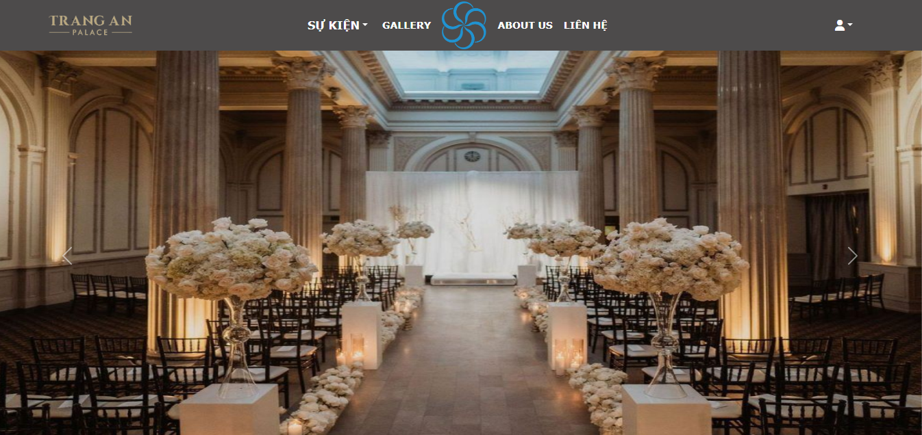

Image 6: Body website

* Footer

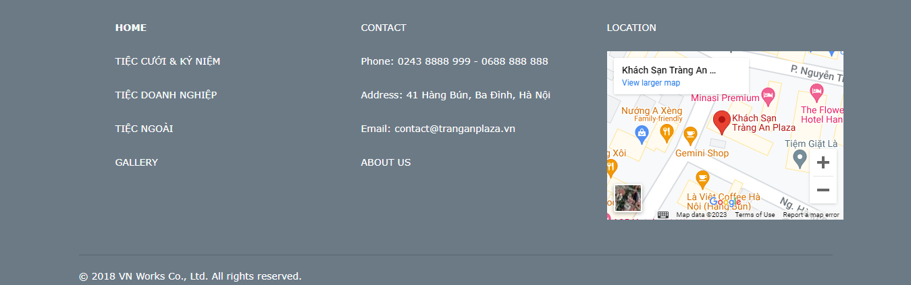

Image 7: Footer

* Login

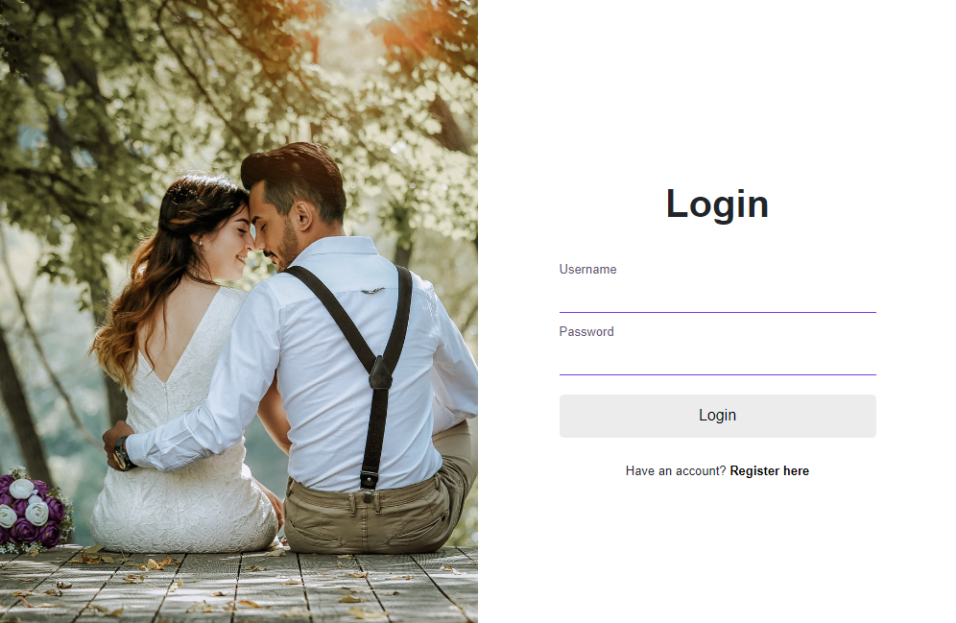

Image 8: Login page

* Register

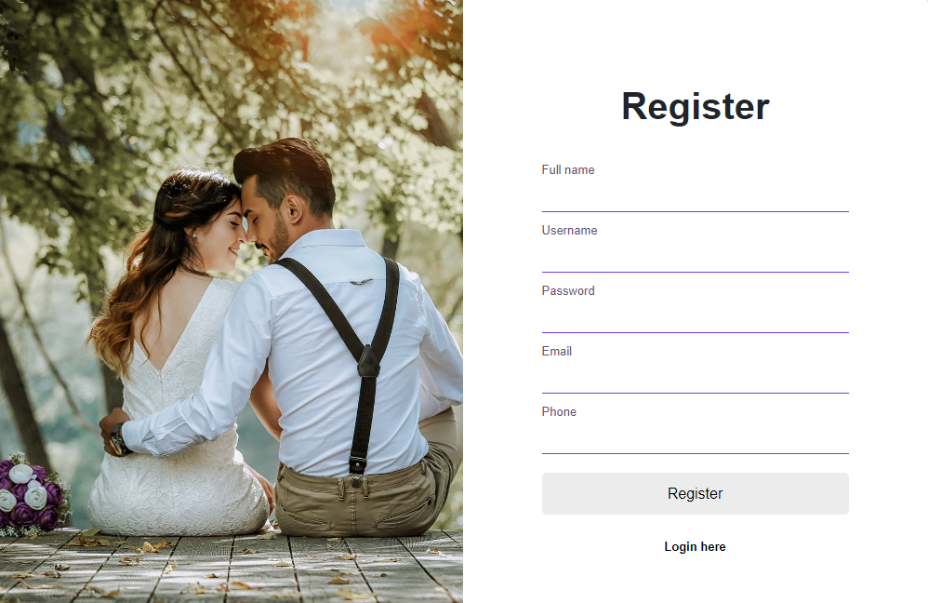

Image 9: Register Page

* Event page

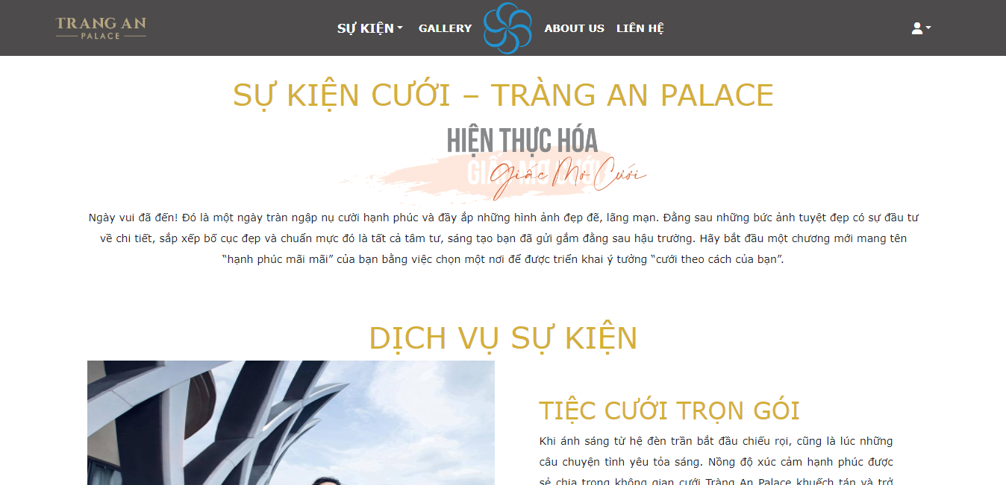

Image 10: Event Page

* Gallery page

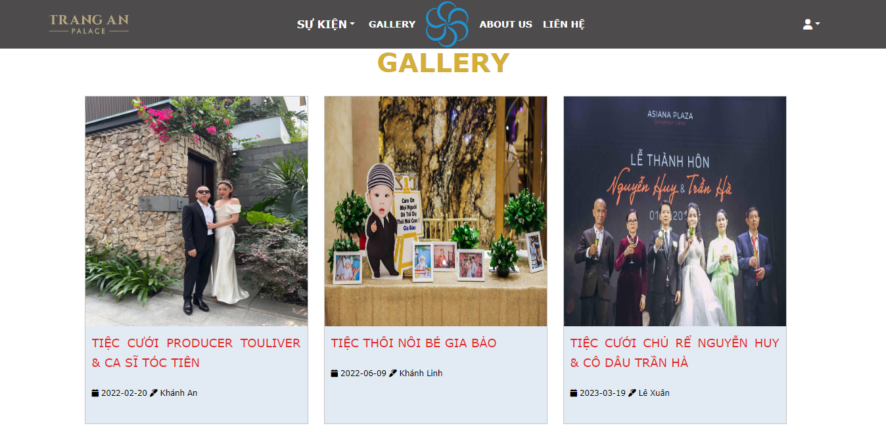

Image 11: Event Page

* Review page

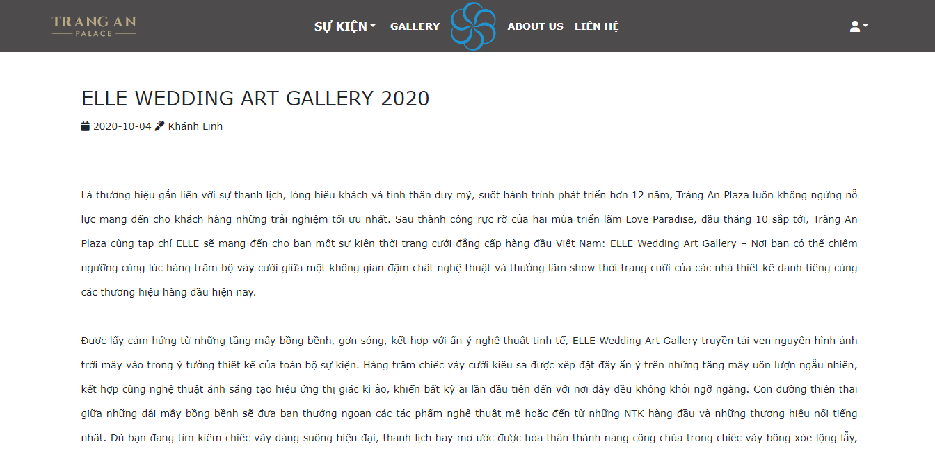

Image 12: Review Page

* About us Page

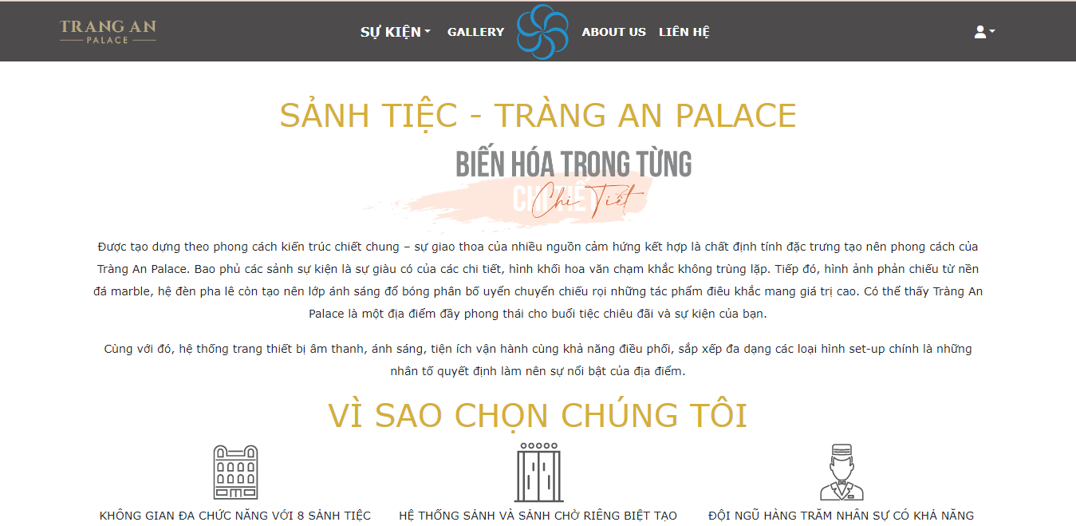

Image 13: Event Page

* Contact page

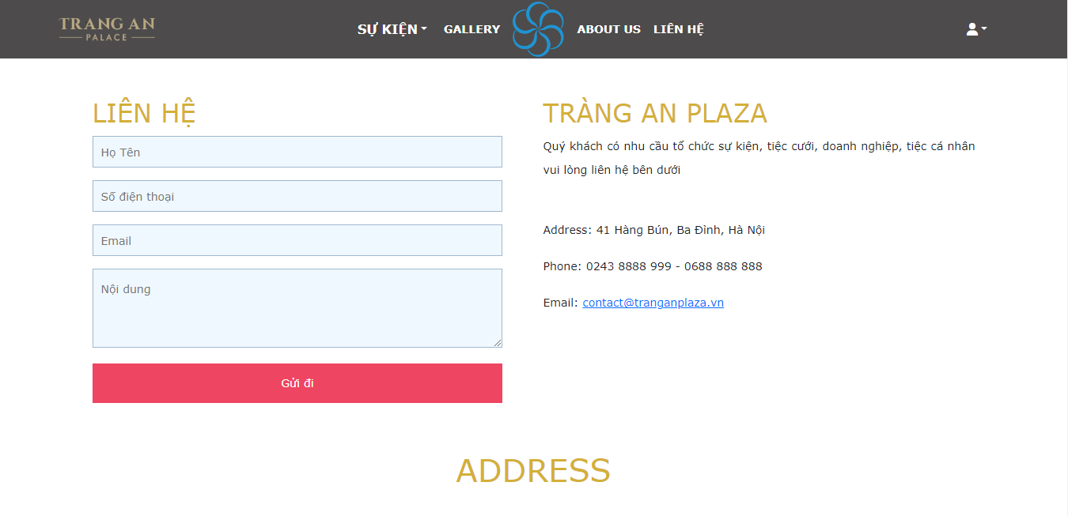

Image 14: Contact Page

* Admin’s Interface
* Admin login page

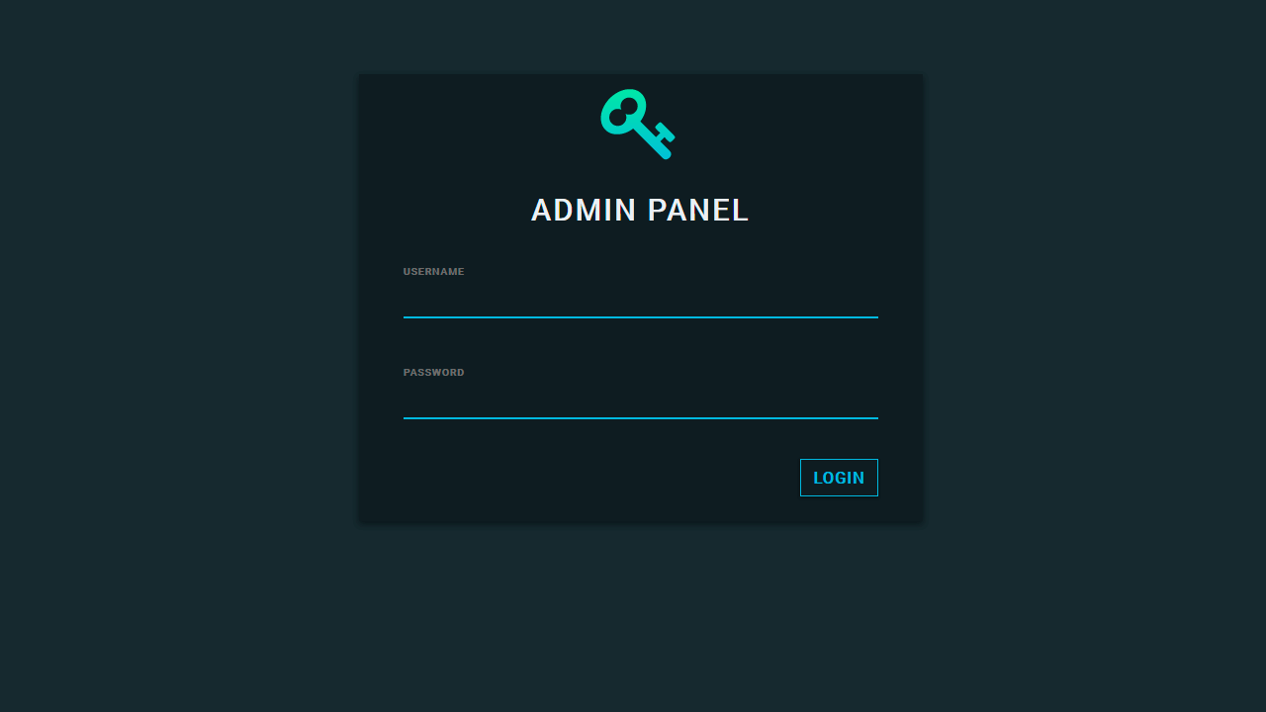

Image 15: Admin login page

* Admin home page

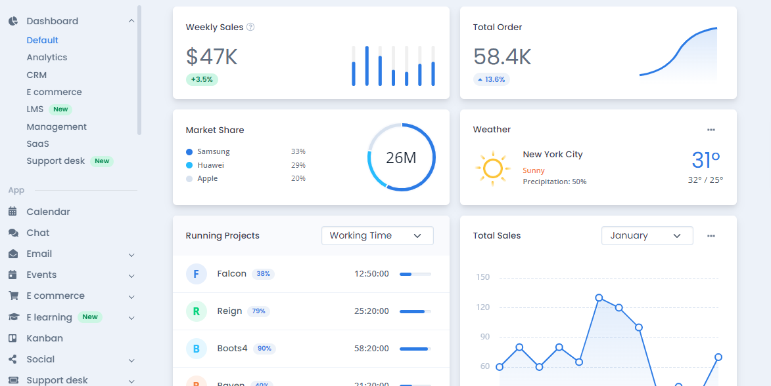

Image 16: Admin home page

* Admin event page

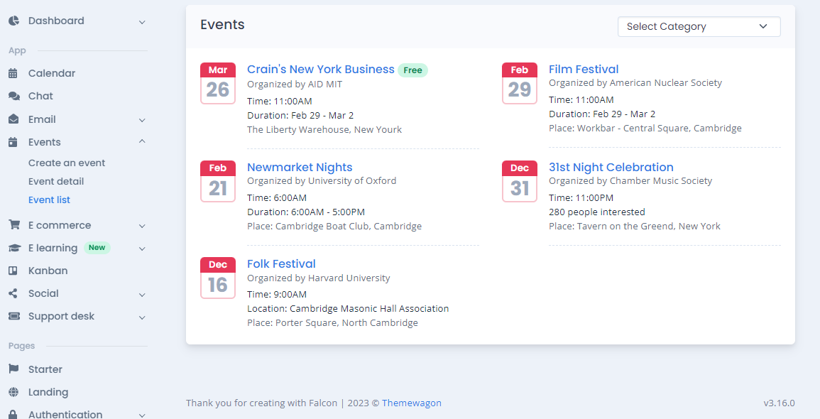

Image 17: Admin event page

* Admin add and edit a new event

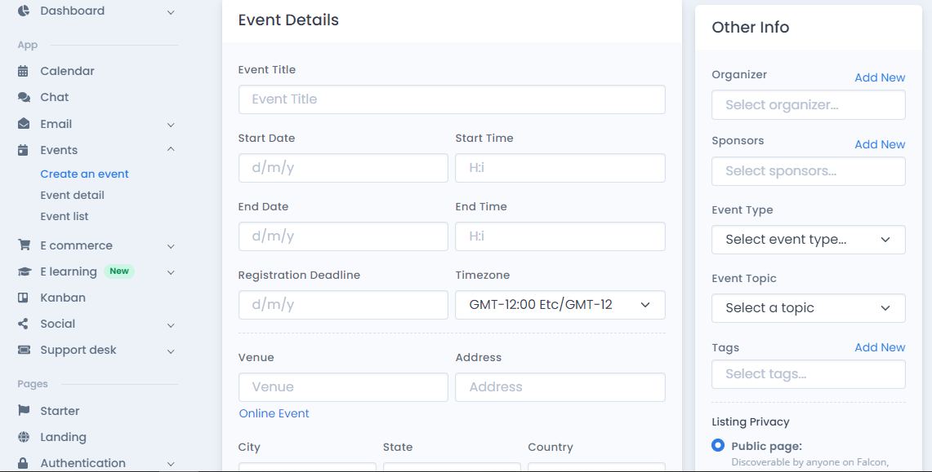

Image 18: Admin add and edit new event

* Algorithm
* Rules for drawing diagram handling of business prodcedures

|  |  |
| --- | --- |
|  | Steps to take |
|  | Check/Approve/Decide |
|  | Begin |
|  | End |

1. User/Customer

* Registration

This process is activated when the customer vistits the website and chooses to register

|  |  |  |
| --- | --- | --- |
| User registration | | |
|  | User | BackEnd |
| Correct  Fail  Register successfully  Fill in registration information  Error message  Login Page  Sign Up | New user registration |

* Describe the steps in the business process

|  |  |  |  |
| --- | --- | --- | --- |
| Step code | Step name | Group of people | Describe |
| 1 | The user chooses to register for a new account | User | When the customer opens the link to the website and select Register |
| 2 | Fill in your account information | User | The account information includes:   * Fullname * Username * Password * Phone * Email |
| 3 | Error message | System | Display an error message to the user when the required information is missing |
| 4 | Add new users | System | The system checks the validity of the information and adds a new account to the system |
| 5 | Error message | System | Display an error message to the user when the process of adding a new account fails |
| 6 | Go to the Login Page | System |  |

* Login

When the user accesses the website and login into the system

|  |  |  |
| --- | --- | --- |
| User Login | | |
|  | User | BackEnd |
| Fail  Correct  Error message  Home Page  Valid login information  Fill in your login information  Login | Check login information |

* Describe the steps in the business process

|  |  |  |  |
| --- | --- | --- | --- |
| Step code | Step name | Group of people | Describe |
| 1 | The user chooses to log in | User | When the customer opens the link to the website and selects Login |
| 2 | Fill in your account information | User | The account information includes:   * Username * Password |
| 3 | Error message | System | Display an error message to the user when one of the two pieces of information is missing |
| 4 | Check login information | System | The system checks the validity of the information |
| 5 | Error message | System | Display an error message the user when the login credentials check fails |
| 6 | Follow the next procedure | System |  |

* List gallery function

|  |  |
| --- | --- |
| List category product | |
| FrontEnd | BackEnd |
| Check login  Article Page  False  Login Page  True  Fill comment  Display script article  Choose article  Go to gallery page  Click gallery on nav bar | Check login and validate  Query article |

* Describe the steps in the business process

|  |  |  |  |
| --- | --- | --- | --- |
| Step code | Step name | Group of people | Describe |
| 1 | Select gallery on nav bar | User | User select gallery page |
| 2 | Choose article from gallery page | User | User select article |
| 3 | Query article | System | Display article from the database |
| 4 | Fill comment | User | User post comment |
| 5 | Check login and valid comment | System | The system checks if the user is logged in and has entered a comment |
| 6 | Login page | System | The system redirects and required the user to login |
| 7 | Article page | System | Display comment from the database |

* Event type

|  |  |
| --- | --- |
| Order and checkout | |
| FrontEnd | BackEnd |
| Hover event on nav bar  Go to event page  Display event script | Query event script |

* Describe the steps in the order and checkout process

|  |  |  |  |
| --- | --- | --- | --- |
| Step code | Step name | Group of people | Describe |
| 1 | Hover event on nav bar | User |  |
| 2 | Go to event page | User | User select event page |
| 3 | Show result of event | System | Display all script of event from the database |

* Log out

|  |  |
| --- | --- |
| Log out | |
|  | User |
| Success  Exit back to the home page  Fail  Error message  Logout success  Logout |

* Describe the steps in the logout

|  |  |  |  |
| --- | --- | --- | --- |
| Step code | Step name | Group of people | Describe |
| 1 | Option to log out of the system | User |  |
| 2 | Proceed to log out users from the system | System |  |
| 3 | Successfully logged out of the system | System |  |

* Manage user info

|  |  |
| --- | --- |
| Manage and view user info | |
| Lane 1 | Lane 2 |
| Error message  Successfully message  Successful fixed  Edit user info  Delete user  List of user  Data found  Error message  Retrieve data successfully  Post data  Manage user info | Edit user  Delete data  Get a list of info |

* Describe the steps in process

|  |  |  |  |
| --- | --- | --- | --- |
| Step code | Step name | Group of people | Describe |
| 1 | Access order database | Admin |  |
| 2 | Get information of users | System |  |
| 2.1 | Error message | System | If you can’t get user information |
| 3 | Return user’s information | System | Information includes:   * User name * Email * Phone number |
| 4 | Edit user detail | Admin | Change the user detail |
| 5 | Submit change | Admin |  |
| 5.1 | Error message | System | Error detail |
| 6 | Successfully edited | System | Notify the changed info |
| 7 | Delete user | Admin |  |
| 8 | Successfully deleted | System |  |

* Process of adding event

|  |  |
| --- | --- |
| Adding new event | |
| Admin | BackEnd |
| Fill event form  Successfully post  Fail show error message  Posting information  Submit after filling informations  Click add event | Save information  Show add event form |

* Describe the steps in adding event process

|  |  |  |  |
| --- | --- | --- | --- |
| Step code | Step name | Group of people | Describe |
| 1 | Option to post information | Admin |  |
| 2 | Fill in the information | Admin | Fill in the following information:   * Event type ID * Event type * Event intro * Event detail * Event service * Event food |
| 3 | Send information | System |  |
| 3.1 | Error message | System | If the upload process fails |
| 4 | Successful message | System | If the new event is successfully posted |

* Procedure edit event

|  |  |
| --- | --- |
| Edit event | |
| Admin | BackEnd |
| Fill edit event form  Click edit event  Successfully post  Fail show error message  Posting information  Submit after filling informations | Save information  Show add event form |

* Describe the steps in the business process

|  |  |  |  |
| --- | --- | --- | --- |
| Step code | Step name | Group of people | Describe |
| 1 | Choose to edit details of an event | Admin |  |
| 2 | Get edit form | System |  |
| 3 | Fill the edit form | Admin | Change the information of the event |
| 4 | Submit the form | Admin | Submit the edited information of the event |
| 4.1 | Error message | System | Show error information in the submit form |
| 5 | Successfully edited | System |  |

* Delete event

|  |  |
| --- | --- |
| Delete event | |
| Admin | BackEnd |
| Remove successfully  Click delete | Remove event from database |

* Describe the steps in the business process

|  |  |  |  |
| --- | --- | --- | --- |
| Step code | Step name | Group of people | Describe |
| 1 | Select event want to delete | Admin |  |
| 2 | Remove product from database | System |  |
| 3 | Remove successfully | System |  |
| 4 | Return to event database list | System | Show updated list of event |

* Manage and view user request

|  |  |
| --- | --- |
| Manage and view user request | |
| Lane 1 | Lane 2 |
| Manage user’s request  List of request  Data found  Error message  Successfully message  Successful fixed  Edit user info  Delete request  Error message  Retrieve data successfully  Post data | Edit request  Delete data  Get a list of request |

* Describe the steps in the process

|  |  |  |  |
| --- | --- | --- | --- |
| Step code | Step name | Group of people | Describe |
| 1 | Access request database | Admin |  |
| 2 | Get request information | System |  |
| 2.1 | Error message | System | If you can’t get user information |
| 3 | Return user’s order information | System | Information includes:   * Username * Email * Phone number |
| 4 | Edit request detail | Admin | Change the request detail |
| 5 | Submit change | Admin |  |
| 5.1 | Error message | System | Error detail |
| 6 | Successfully edited | System | Notify the changed request |
| 7 | Delete request | Admin |  |
| 8 | Successfully deleted | System | Notify the deleted request |

1. **Task sheet:**

|  |  |  |  |  |
| --- | --- | --- | --- | --- |
| Task | Start time | Finish time | Implemented by | Evaluation  (%) |
| ***Feasibility study phase*** | | | | |
| Create memo | 17/04/2023 | 21/04/2023 | Dang Dinh Thuan | 25 |
| Create opinions | 17/04/2023 | 21/04/2023 | Le Tien Tai | 25 |
| Create opinions | 17/04/2023 | 21/04/2023 | Pham Doan Toan | 25 |
| Create opinions | 17/04/2023 | 21/04/2023 | Le Thanh Dat | 25 |
| ***Requirement Analysis phase*** | | | | |
| Create memo | 17/04/2023 | 24/04/2023 | Dang Dinh Thuan | 25 |
| Create opinions | 17/04/2023 | 24/04/2023 | Le Tien Tai | 25 |
| Create opinions | 17/04/2023 | 24/04/2023 | Pham Doan Toan | 25 |
| Create opinions | 17/04/2023 | 24/04/2023 | Le Thanh Dat | 25 |
| ***Development phase*** | | | | |
| BA- Create Database | 24/04/2023 | 28/04/2023 | Dang Dinh Thuan | 10 |
| FE- Design Home Page | 24/04/2023 | 01/05/2023 | Le Tien Tai  Le Thanh Dat | 10 |
| FE- Design Event Page | 01/05/2023 | 05/05/2023 | Dang Dinh Thuan | 5 |
| FE- Design Gallery Page | 26/04/2023 | 01/05/2023 | Le Tien Tai | 3 |
| FE- Design Article of Gallery Page | 01/05/2023 | 05/05/2023 | Le Thanh Dat | 3 |
| FE- Design About us Page | 05/05/2023 | 10/05/2023 | Pham Doan Toan | 3 |
| FE- Design Contact Page | 05/05/2023 | 10/05/2023 | Pham Doan Toan | 3 |
| FE- Design Admin Page | 01/05/2023 | 04/05/2023 | Dang Dinh Thuan  Le Tien Tai | 10 |
| FE- Design Admin Management pages (list/add/edit/delete) | 24/05/2023 | 07/05/2023 | Le Thanh Dat  Le Tien Tai | 5 |
| FE- Design Login and Register page | 24/05/2023 | 01/05/2023 | Pham Doan Toan | 5 |
| BE- Design event management logic (list/add/edit/delete) | 05/05/2023 | 12/05/2023 | Le Thanh Dat  Dang Dinh Thuan | 10 |
| BE- Design Gallery and Article management logic (list,add,edit,delete) | 01/05/2023 | 05/05/2023 | Le Tien Tai  Le Thanh Dat | 3 |
| BE- Design user management logic (list/add/edit/delete) | 12/05/2023 | 19/05/2023 | Le Thanh Dat  Pham Doan Toan | 7 |
| BE- Design user request logic (list/add/edit/delete) | 17/05/2023 | 24/05/2023 | Dang Dinh Thuan | 7 |
| BE- Design account/role-account management logic (list/add/edit/delete) | 20/05/2023 | 26/05/2023 | Pham Doan Toan  Le Tien Tai | 8 |
| BE- Design User Login/Logout/Sign up | 24/04/2023 | 01/05/2023 | Pham Doan Toan | 6 |
| BE- combine code BE and FE | 01/05/2023 | 07/05/2023 | Dang Dinh Thuan | 4 |
| ***Testing phase*** | | | | |
| FE- fix event page | 10/05/2023 | 14/05/2023 | Dang Dinh Thuan | 25 |
| BE- fix comment Article logic | 12/05/2023 | 18/05/2023 | Le Tien Tai | 25 |
| FE- fix login/register page | 02/05/2023 | 07/05/2023 | Pham Doan Toan | 25 |
| FE- Complete web layout | 15/05/2023 | 22/05/2023 | Le Thanh Dat | 25 |
| ***Deployment phase*** | | | | |
| BE- Submit Source code | 27/05/2023 | 29/05/2023 | Dang Dinh Thuan | 25 |
| BA- Submit project doc and Slide | 28/05/2023 | 29/05/2023 | Le Tien Tai | 25 |
| BE- Review Video | 27/05/2023 | 29/05/2023 | Pham Doan Toan | 25 |
| Be- Submit Task Sheet | 28/05/2023 | 29/05/2023 | Le Thanh Dat | 25 |

1. **Validation Checklists**:

|  |  |
| --- | --- |
| Option | Validated |
| Do all image links lead to the appropriate Website? | Yes |
| Are all the images and link visible on the page? | Yes |
| Is the Web page taking too long to load? | No |
| Is the Web page opening properly in all the tested Web browsers? | Yes |
| Login form has been validated? | Yes |
| Registration form has been validated? | Yes |
| Contact form has been validated? | Yes |

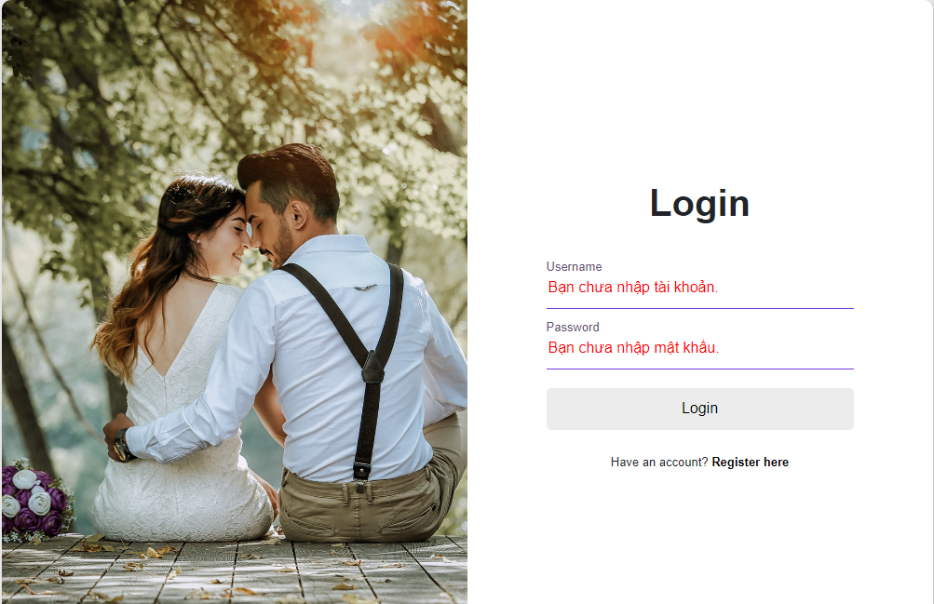

* Login form has been validated.

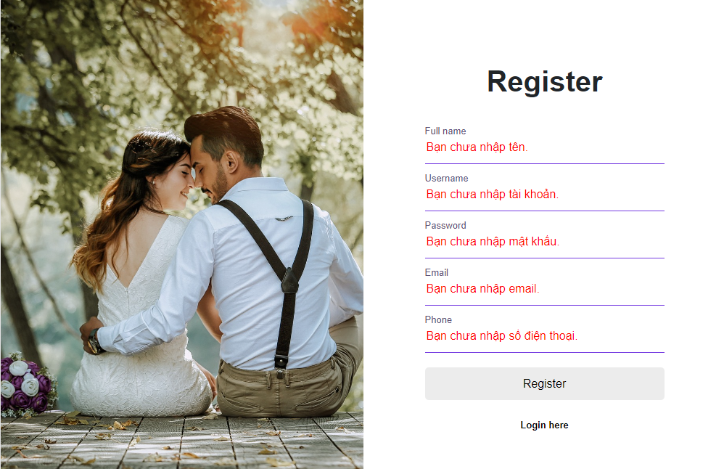

* Registration form has been validated.

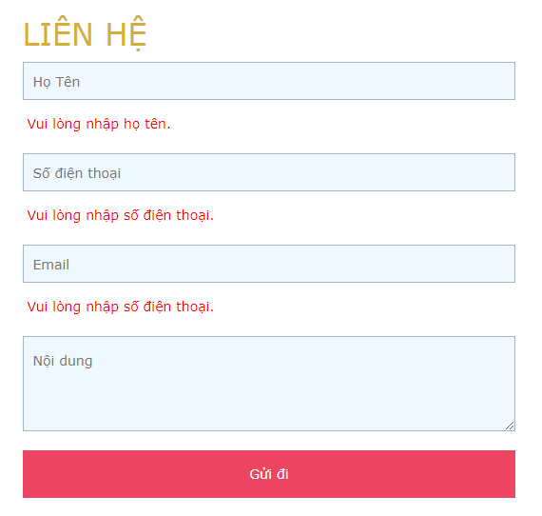

* Contact form has been validated.